34.96: a) With two lenses of different focal length in contact, the image distance from the first lens becomes exactly minus the object distance for the second lens. So we have:
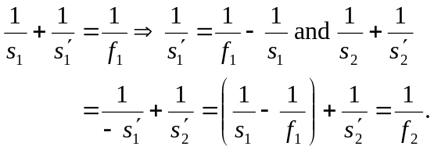
But overall for the lens system, 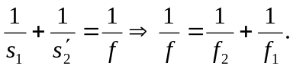
b) With carbon tetrachloride sitting in a meniscus lens, we have two lenses in contact. All we need in order to calculate the system’s focal length is calculate the individual focal lengths, and then use the formula from part (a).
For the meniscus: 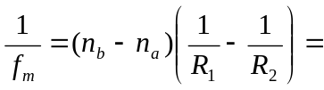
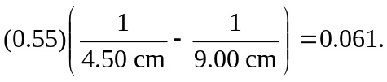
For the 